ON THIS SCREEN MAKE SURE YOU PUT YOUR NAME IN THE BOX WITH THE RED CIRCLE AS THIS WILL ENABLE ME TO RECONCILE PAYMENTS COMING THROUGH TO THE ACCOUNT

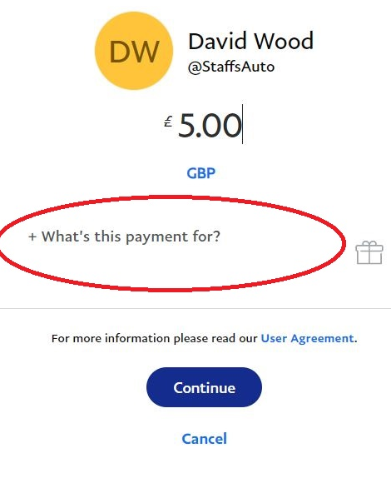
MAKE SURE THIS IS SET TO FAMILY AND FRIENDS IF IT IS NOT ALREADY. IF YOU DON’T CHARGES WILL BE DEDUCTED AND THE CLUB WON’T RECEIVE THE FULL MEMBERSHIP FEE

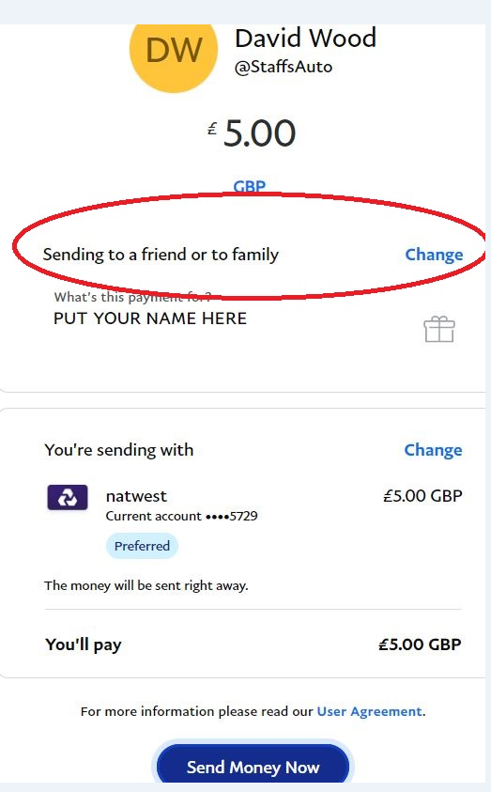
THIS IS WHAT I GET IF YOU COMPLETE THE PAYMENT AS ABOVE, SO I CAN SEE THE MEMBER NAME ON THE PAYMENT. IT YOU USE SOMEONE ELSE’S PAYPAL ACCOUNT TO MAKE THE PAYMENT, SPOUSE, PARTNER, COMPANY ETC, WITHOUT YOUR NAME I’M NOT GOING TO KNOW WHO IT CAME FROM
