Process for renewing your ACU Membership / Trials registration

To renew an ACU membership for 2023 successfully you must have membership of an ACU club for 2023. There are two ways of renewing a club membership:

1 – Your club has set up the Sport80 club web page and Stripe account which has a function to take out club membership. Selecting this function generates a payment screen where you input a card payment and select Join Club. The payment is made directly to the club account and you are taken into the ACU Sport80 website to complete the renewal process in your member profile. As you have paid the fee directly to the club your club membership is automatically accepted and updated to 2023

2 – You pay your membership fee to the club by other means, cash, cheque, paypal, bank transfer etc and manually renew your membership through your profile on the Sport80 site. When you have completed the process your membership renewal will have to be approved by a club official after confirming receipt of your payment. The request is sent to the official by email so how quickly it is approved depends on when they see the email.

Whichever of these two methods you use to renew your club membership, the remaining processes for renewing your licence and ACU membership are the same. Check with your club which method they prefer. Not all clubs have set up the web page for joining so only option 2 is available. For this club, STAFFORD AUTO, use option 2

This example is a walkthrough of process 2 using screenshots of the pages you need to complete.

It is for a trials competitor renewal only. If you want to renew both a trials and enduro licence for example, each have their own record in the ACU Licence category on your profile so I guess you renew both using the same process but I don’t know how the system works for paying the correct amount at final checkout. On the old system an enduro or motocross licence would cover you for trials but on this new one, not sure how it works

In this example the member renewing has a present licence that is current so their licence status shows as a green CURRENT button. If your licence has lapsed it will show as a red LAPSED button but the process is presumably the same. IF YOU ARE NOT ALREADY AN ACU ACCOUNT HOLDER YOU WILL FIRST HAVE TO USE THE JOIN NOW OPTION FROM THE SPORT80 OME PAGE AND CREATE AN ACCOUNT, THEN FOLLOW THIS GUIDE.

This is by no means a comprehensive guide of how the functions work fully, it’s just based on my own renewal and exploring the system using a club members account. It should hopefully be enough to help other members who have not yet got on the system to get signed up for 2023

There are 4 categories that need to be completed to renew membership:

- Renew club membership - CLUB AND TEAM AFFILIATIONS
- Renew medical questionnaire - MEDICAL DOCUMENTATION
- Renew licence - ACU COMPETITOR LICENCE
- Renew ACU membership - MEMBER DETAILS

What we term a licence fee is actually a membership fee so you aren’t presented with a payment screen until completing the ACU membership element in Member Details.
There is no validation that forces you to complete all 4 of these categories together or in any order. It’s possible to just complete the licence category for example. This is why some members have renewed their licence category, received their 2023 e-licence by email and not been asked for payment, as the checkout and payment is only available on the ACU membership category. Similarly, if you complete just the ACU Membership category and pay the £20 fee you probably won’t receive your e-licence as you haven’t competed the ACU Competitor Licence category. Unless all 4 of the above categories are completed, your new e-licence (if you received one) will become invalid on 1st January. Therefore if you have only completed one or two categories you need to also complete those not done.

If you have not yet logged onto the new sport80 site and set a new password you will need to do this first. Do this by using your email address that you have always had registered with the ACU (ie: the one they have sent emails to you if in any doubt). If you have already set your password just log in

Access sport80 using this link Sport80 (not sure how reliable this link is so if you don’t already have it just google ACU sport80 and you should get the new login page)

Sport80 uses your email address as your user ID, not member number like the old system. To set a password enter your email address and then select Forgot Password – you will receive an email to set your password, when done, log in using your email as the user ID

When you have logged on it will open the following screen, Fig 1. Just answer the privacy and T&C questions and you will be taken into your member profile page Fig 2

Fig 1

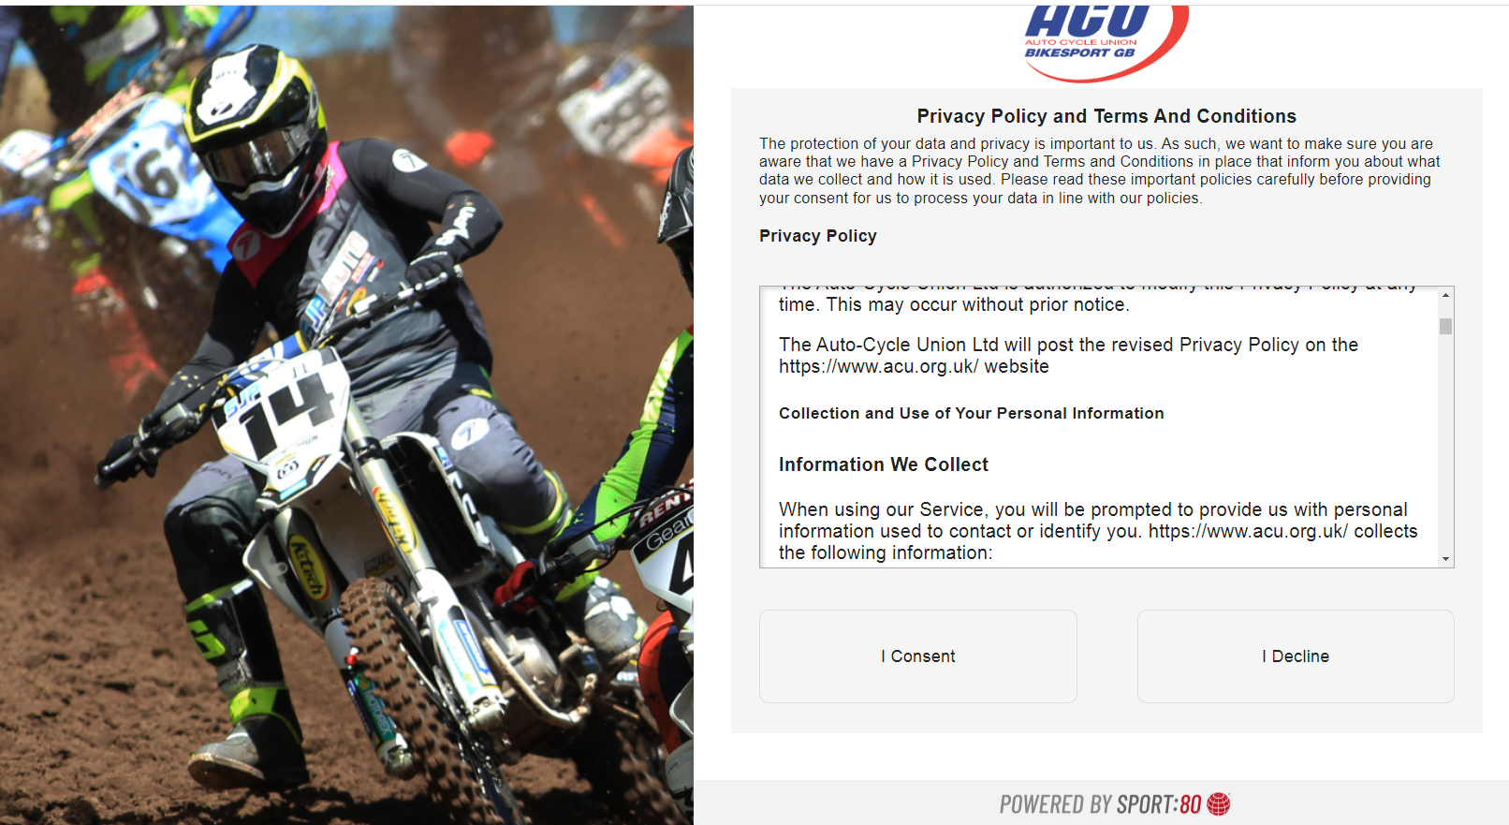

Fig 2

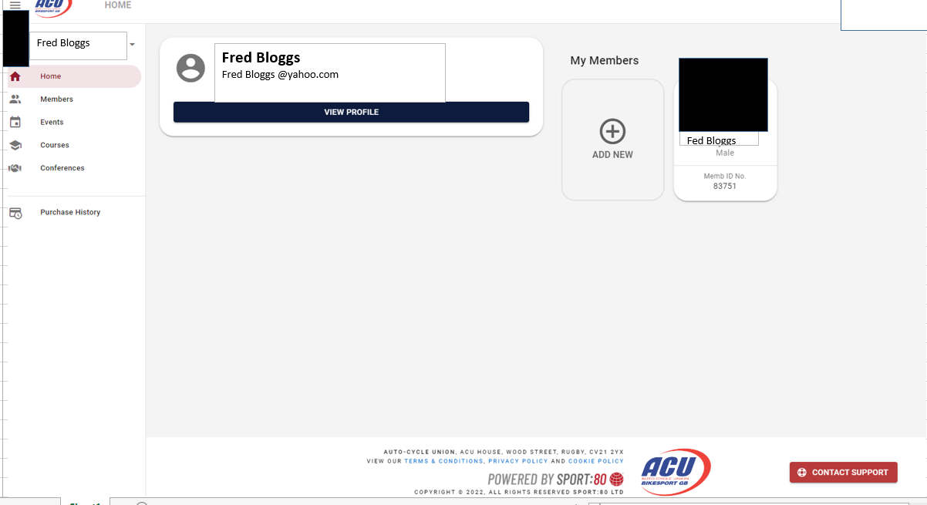

In Fig 2 click VIEW PROFILE or click on the box with your profile image (blacked out here) in order to produce your profile menu Fig 3

Fig 3
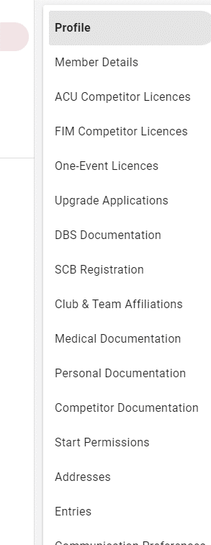

RENEW CLUB MEMBERSHIP

To renew club membership click on club and team affiliations in Fig 3 which will produce the club membership renewal page Fig 4

Fig 4

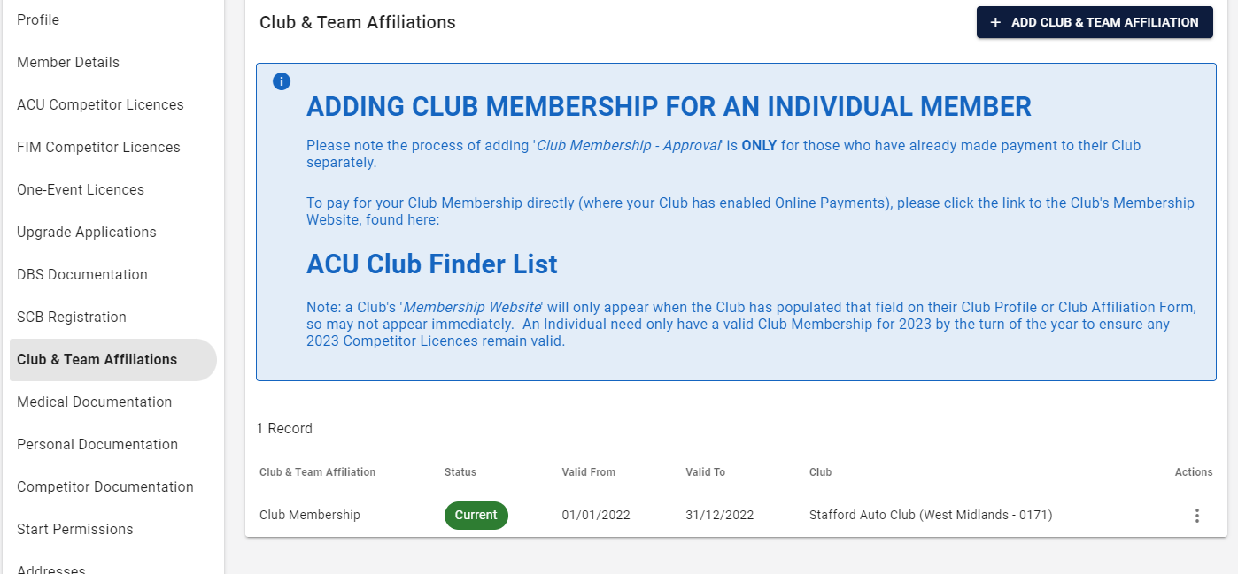

In Fig 4 Disregard the information about ACU club finder as that is only appropriate if you are renewing via a sport80 club webpage that your club has set up and paying directly into the club stripe account. This process is using the Approval Required method.
Select the green CURRENT button (click or double click) to start the renewal process. This will produce a series of screens in which you select various options starting with Fig 5

Fig 5

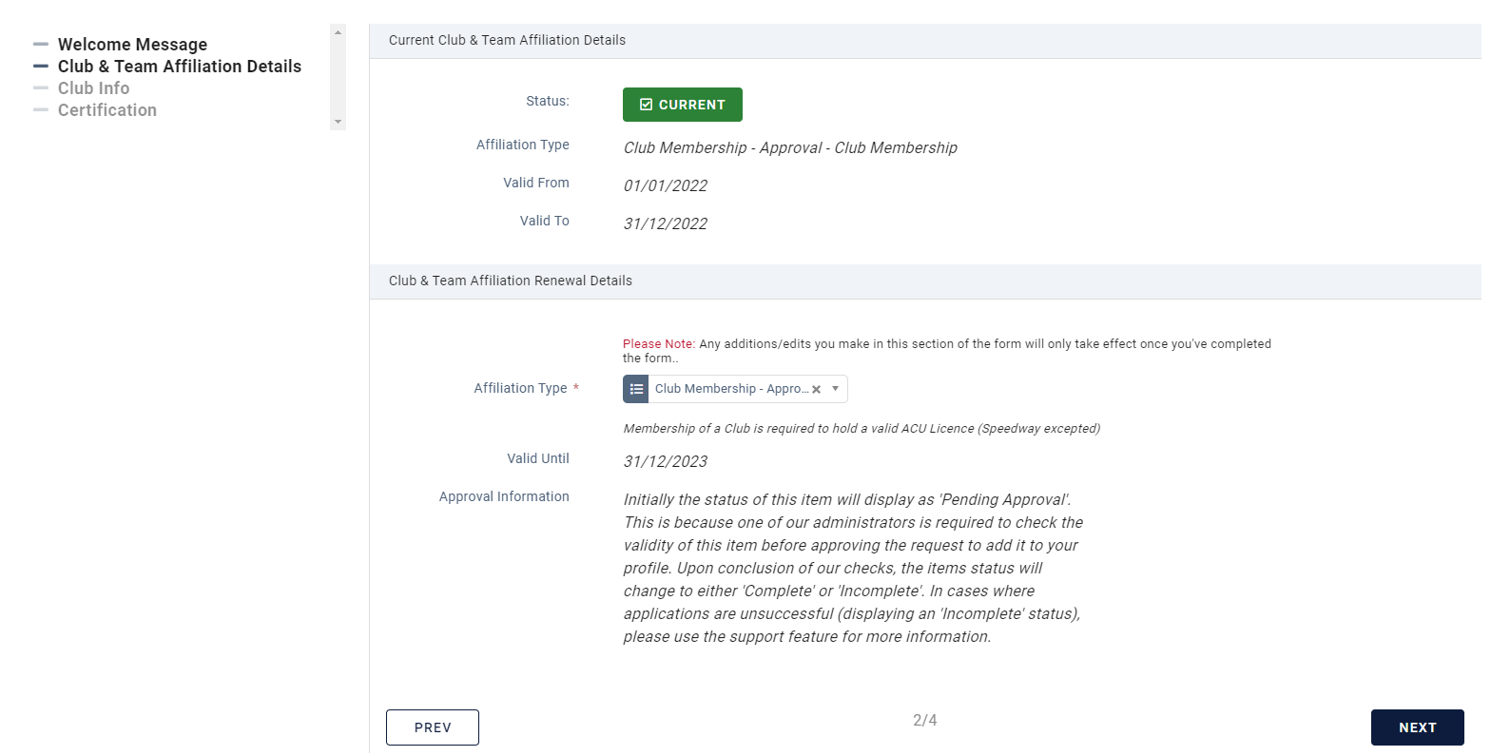

The top half of Fig 5 shows your present membership and status. The Affiliation Type should default to Club Membership – Approval. The bottom half shows the date you will be renewing to.
Select NEXT for the next screen Fig 6

Fig 6

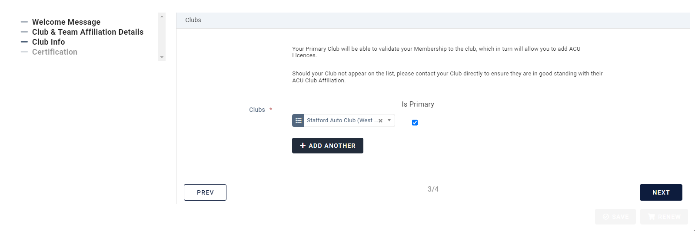

This screen will (I assume) default to your current club which should be your primary club. Tick the box to confirm.
This is the club that membership will be renewed to, so make sure it is the club you pay the membership fee to if more than one club is shown.
Don't add another club at this stage as it might just complicate things……. You can change the primary, just don't add another

Select NEXT for the next page which is Fig 7

Fig 7

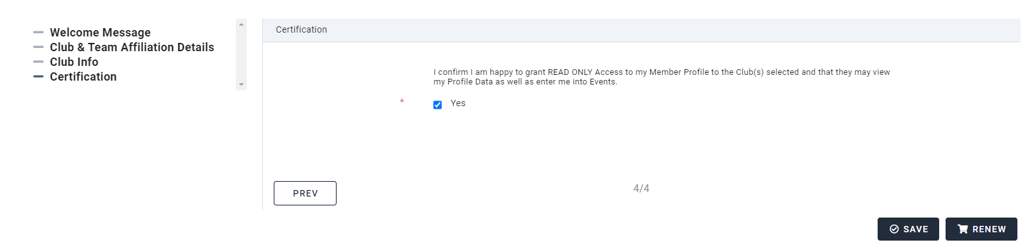

In Fig 7 check the YES box and then select the RENEW button to complete the process for club membership renewal

You will now get this message Fig 8. Your club will approve the membership when they have payment

Fig 8

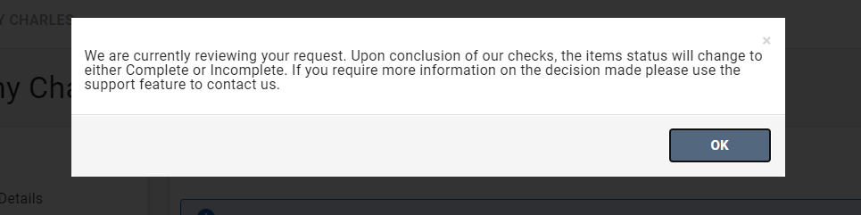
Until approved your club membership status will show as pending as shown below and expiry will still be 2022 Fig 9

Once approved your club membership status will return to current (regardless of the wording in Fig 8) and expiry will be 2023. You won’t receive notification when done, it is a club official who does the approval and they will only see the request when they check their email, so maybe same or the following day.

Fig 9
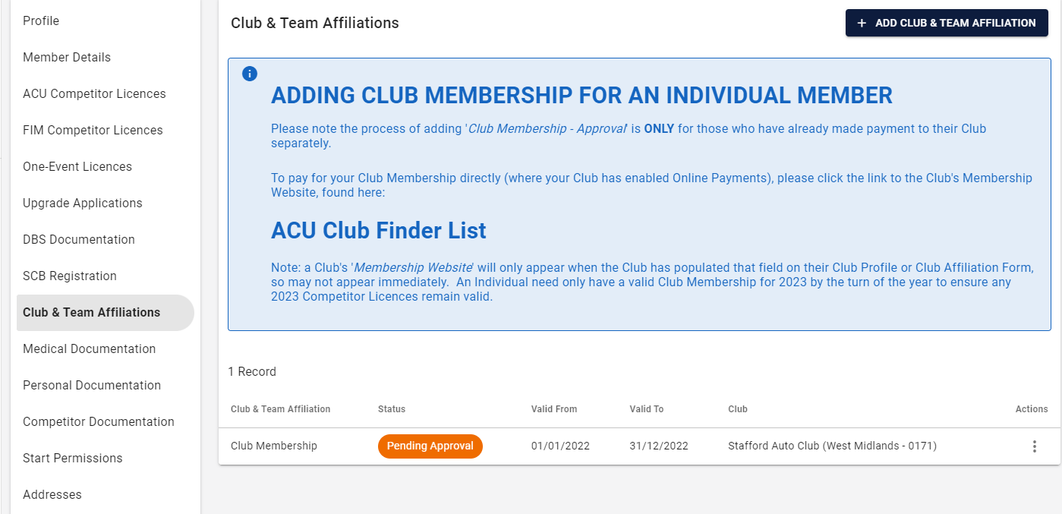

That completes club membership renewal, next renewal is medical documentation
RENEW MEDICAL DOCUMENTATION

From your profile menu (Fig 3) select Medical Documentation

This generates the following screen Fig 10

Fig 10

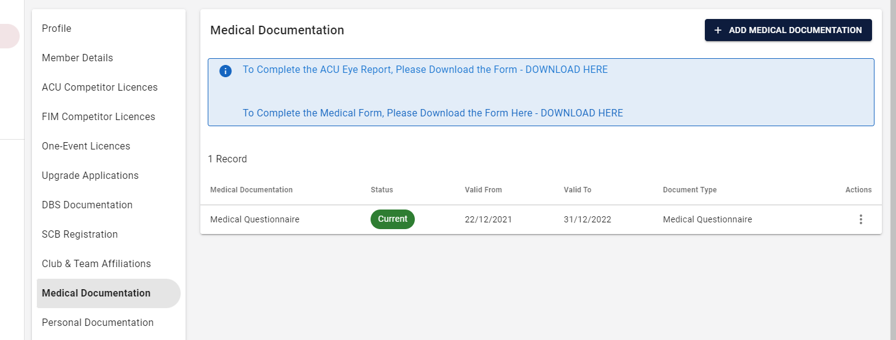

Don’t download either of the documents as they don’t apply to trials registration, just complete the on screen questionnaire as follows. Click on the green CURRENT button which generates the three screens requiring completion Fig 11, 12 and 13

Fig 11

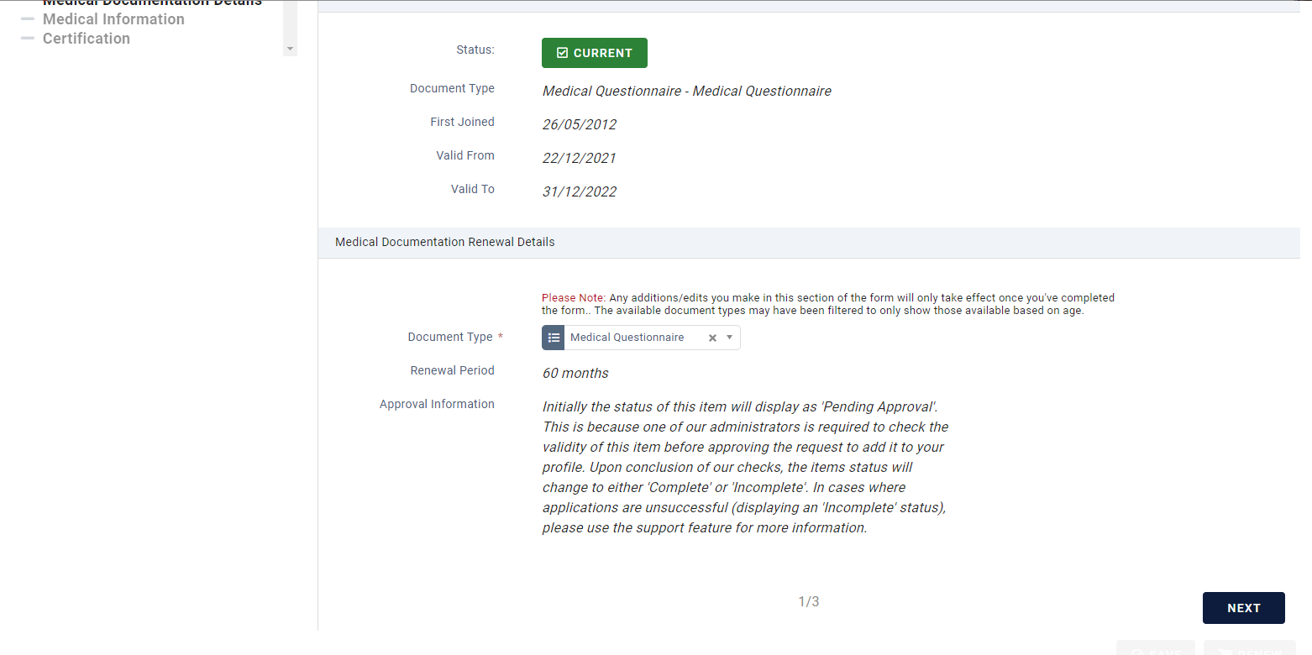

Fig 12

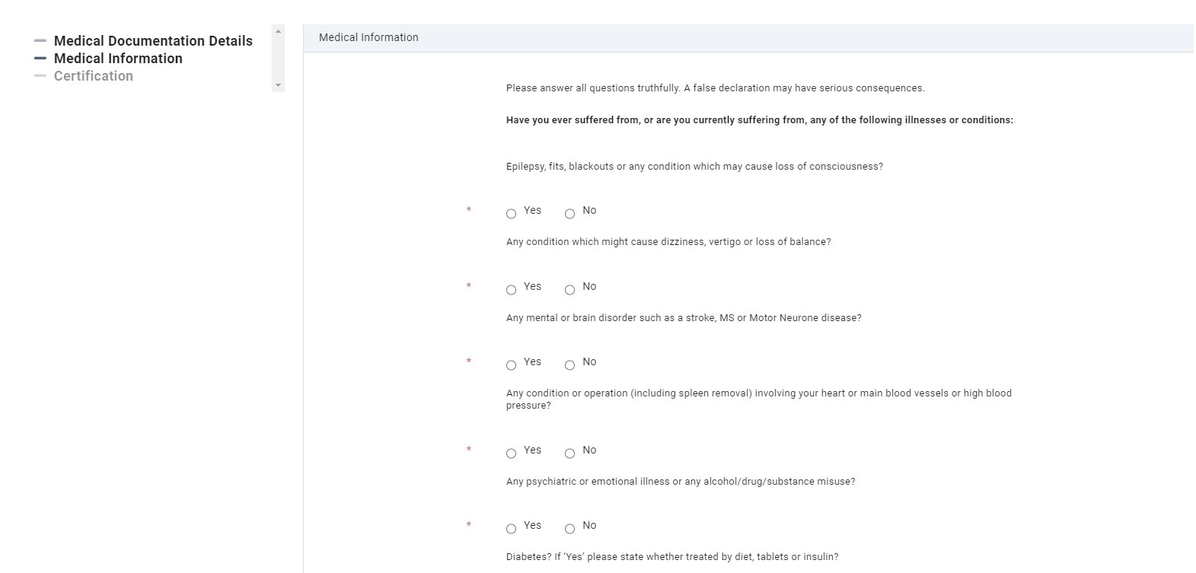

Fig 13

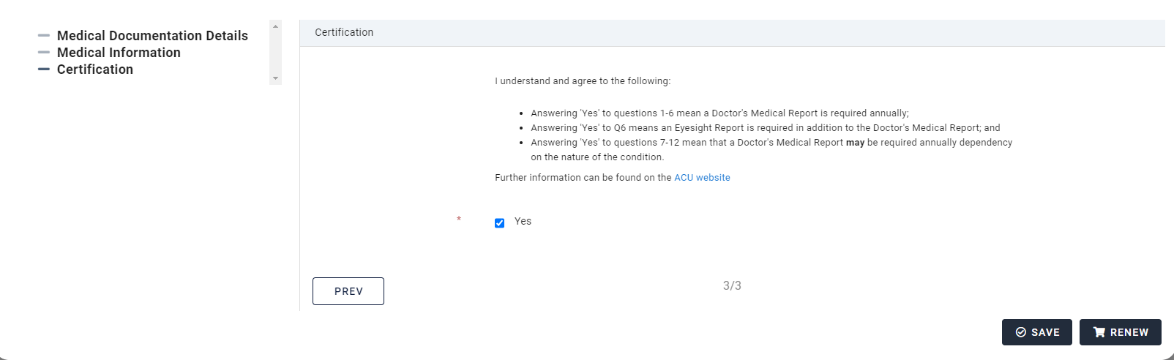

In Fig 13 click RENEW

You will now see the following message Fig 14 advising your request requires ACU approval. Until this is received the status of your Medical Documentation will remain at PENDING APPROVAL. This may take days. Once approved it will return to CURRENT with 2023 expiry.

Fig 14

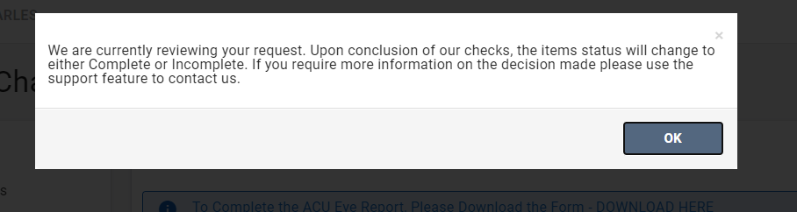

The next process is licence renewal

RENEW ACU COMPETITOR LICENCE

From your profile menu (Fig 3) select ACU Competitor Licence which will produce the following screen Fig 15. The example shows multiple licences but we are only dealing with Trials. To renew multiple disciplines, the process is not clear so hopefully some instruction will be forthcoming from the ACU soon

Fig 15

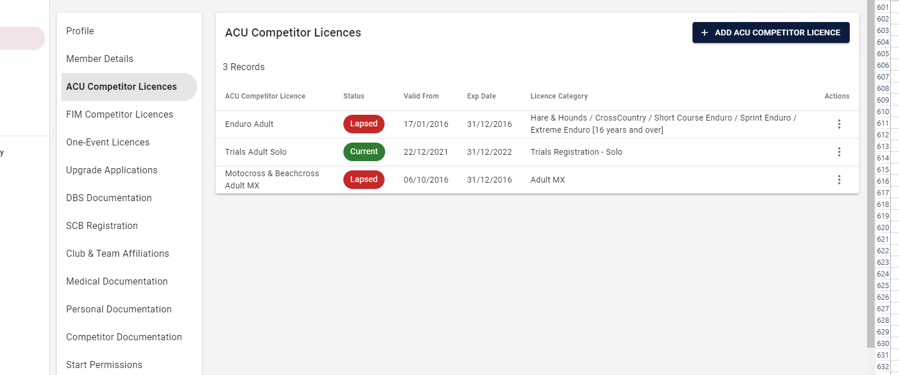

Click on CURRENT in order to start the renewal process. You will see the following screen Fig 16

Fig 16

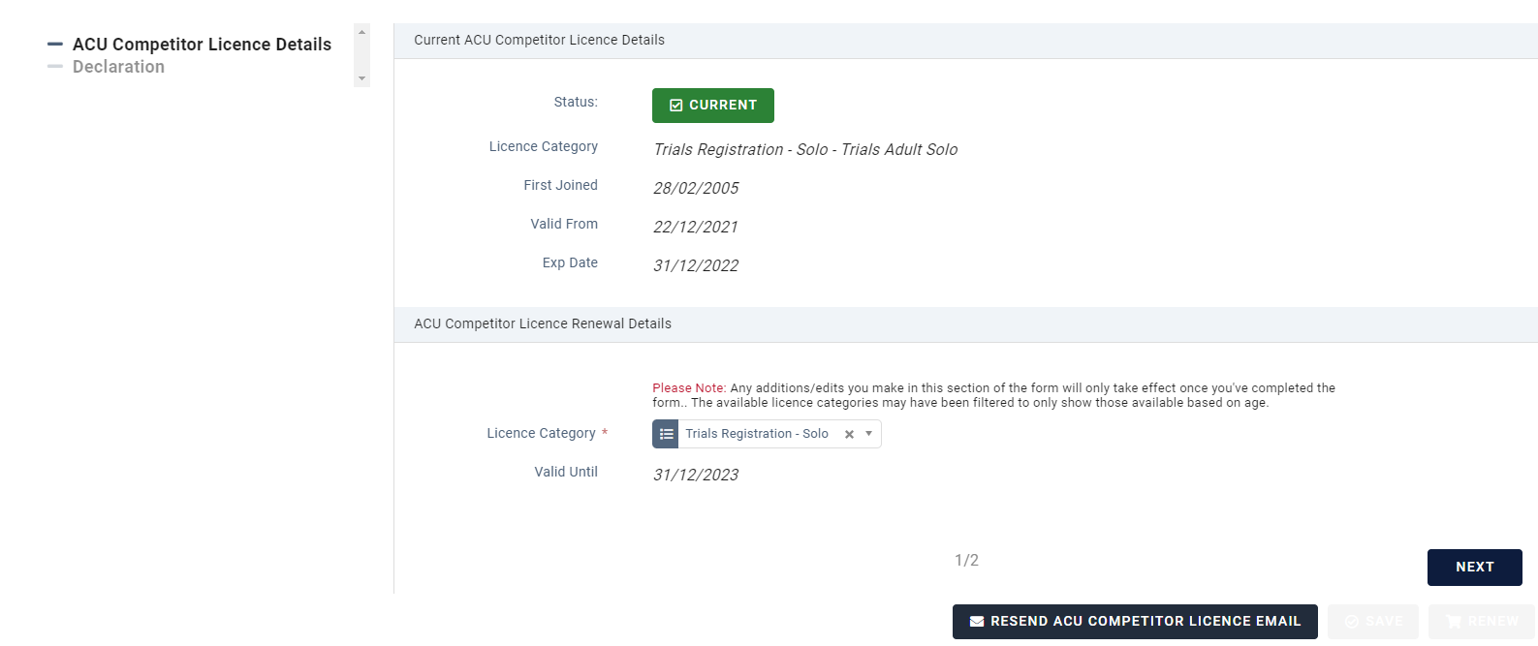

Ensure the category is Trials Registration and select NEXT which will generate the declaration and renewal screen Fig 17

Fig 17

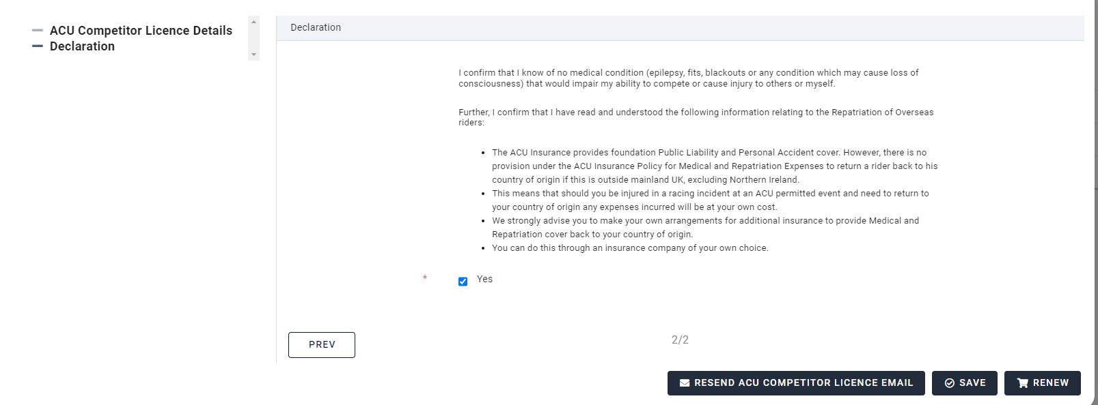

Select RENEW

My computer froze temporarily at this point so I lost the next screenshot, so going from memory

You should now see a message (no screenshot of this) asking you to either ADD MEDICAL DOCUMENT (already done) or ADD MEMBERSHIP. The membership relates to ACU membership, not club membership which has already been done in the first of these processes

Select ADD MEMBERSHIP - if you don’t see this option just choose Member Details from the profile menu (Fig 3) which will take you to the same screen which is Member Details Fig 18
RENEW ACU MEMBERSHIP

Fig 18

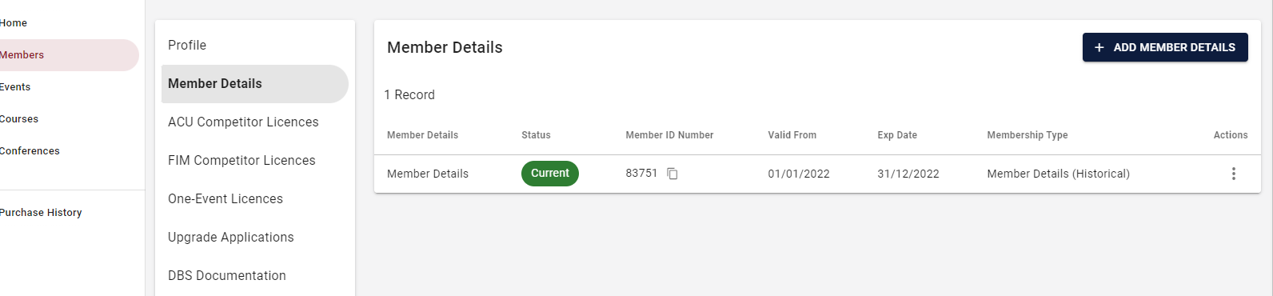

This shows your present ACU membership as current. Click on the CURRENT button to begin the renewal process and you will see the following screen Fig 19

Fig 19

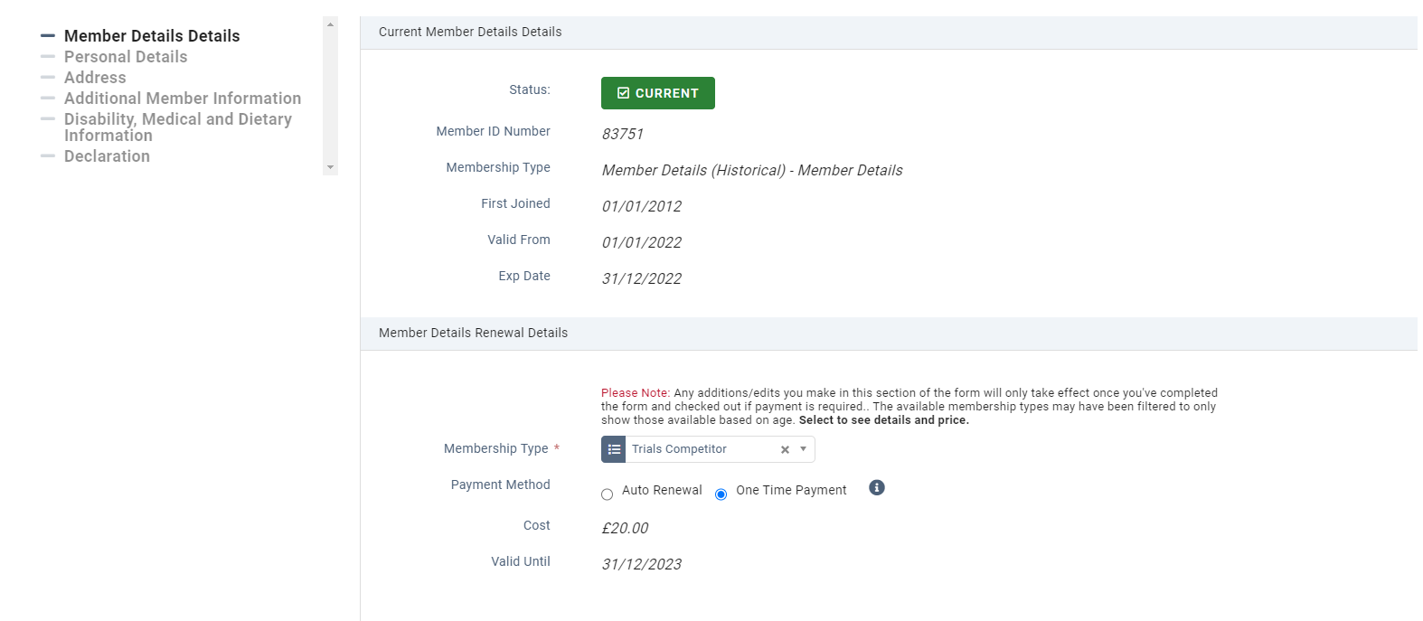

From here, select the membership type as Trials Competitor

If you select Auto Renewal I guess it works the same way as other online auto renewals, you won’t get debited until 31/12 and it will automatically renew and take the ACU membership payment the following year, but whether it automatically completes the processes above that you have just done manually I don’t know. For simplicity I used one time payment as manually going through these screens doesn’t take very long. You will be debited immediately using this option.

Once this screen is completed you will see the Declaration and Renewal screen Fig 20

Fig 20

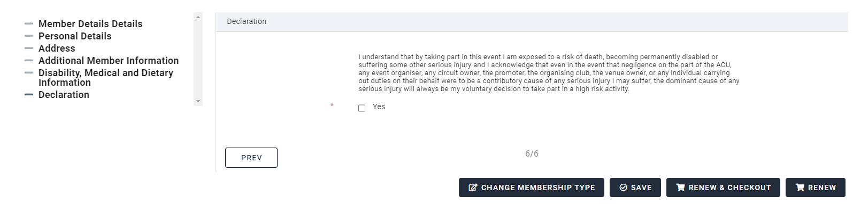

From here select the RENEW AND CHECKOUT option which will renew your membership status and take you to the payment checkout. I can’t add any further screenshots but you may be given the option to either ADD MEMBERSHIP (ignore, already done) ADD LICENCE (ignore, already done) or PAY/CHECKOUT (not sure of exact wording as this was someone else’s account so I couldn’t follow this option to checkout)

However, the option is there to take you to checkout where you can pay the membership fee to complete the process.

You will receive an email from the ACU with your new licence with the option to either download to your phone as an e-licence or as a PDF file that you can print off for a paper version. You actually get this after completing the licence category, it doesn’t wait until the entire process is complete.

You no longer receive a card licence through the post

When all 4 categories are complete, your licence, club membership and medical document categories on your profile should all display a status of COMPLETE (medical document has to wait for ACU approval so may sit at Pending for some days) Your ACU membership status will show CURRENT but the expiry date will still show 2022 IF YOU HAVE A CURRENT 2022 LICENCE, clicking on CURRENT you should see a message saying it will automatically update to 2023 on 31/12/2022 Fig 21 If your licence had lapsed prior to 2022 the expiry will show as 2023

Fig 21

